**Association Rule**

Apriori Intution:

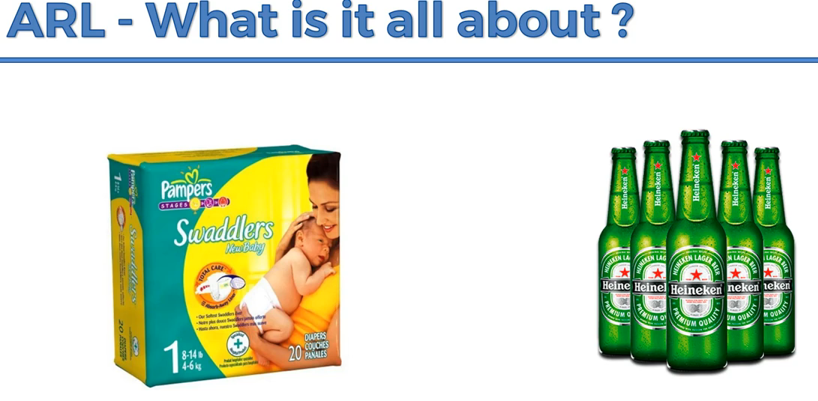

People who buy diaper with bear While analysis the data.

In evening, husband will buy diaper at the same time since it is after work, they will take a bear too.

**Apriori:**



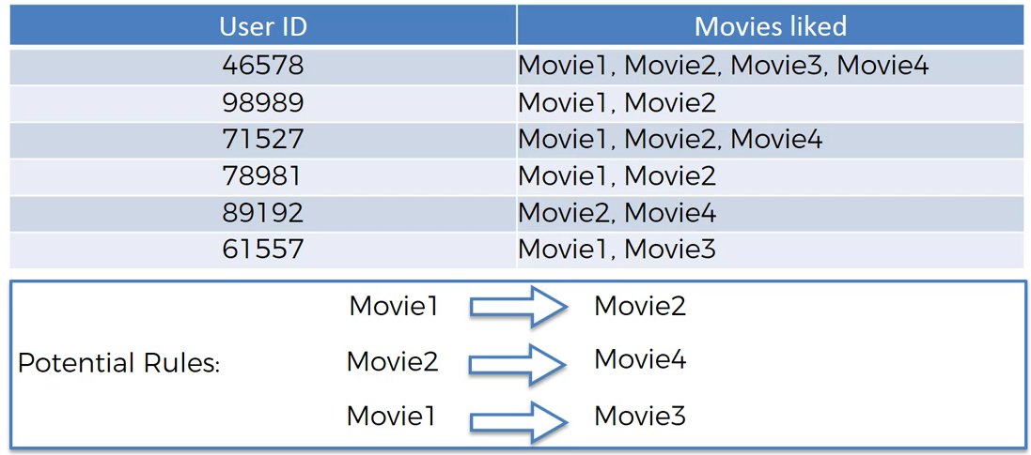

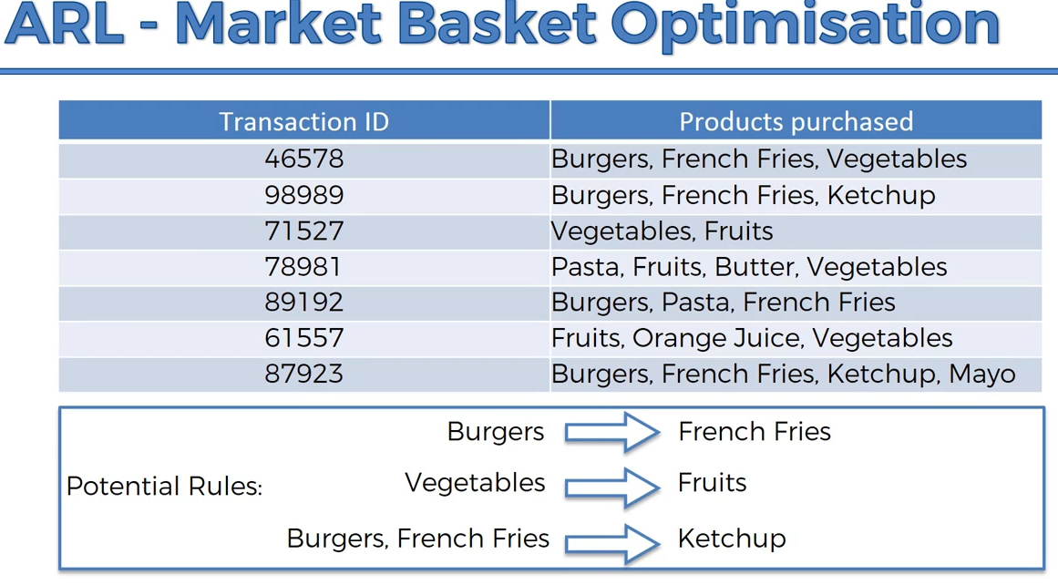

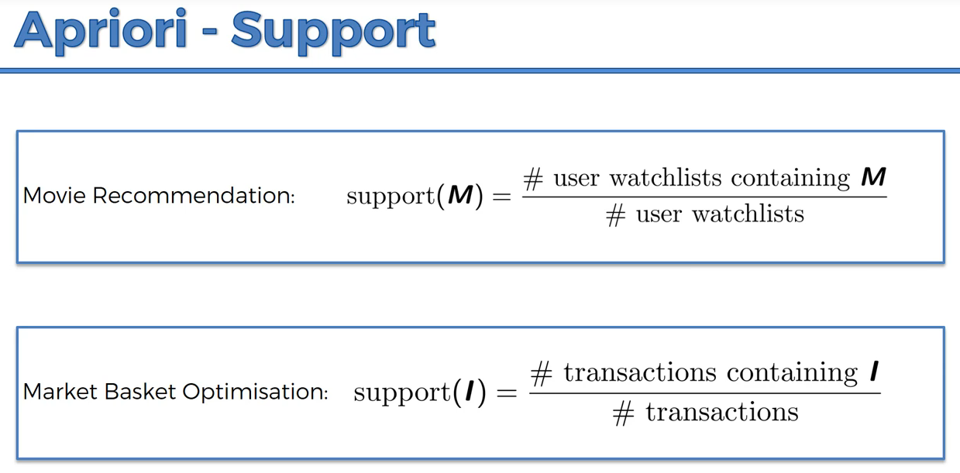

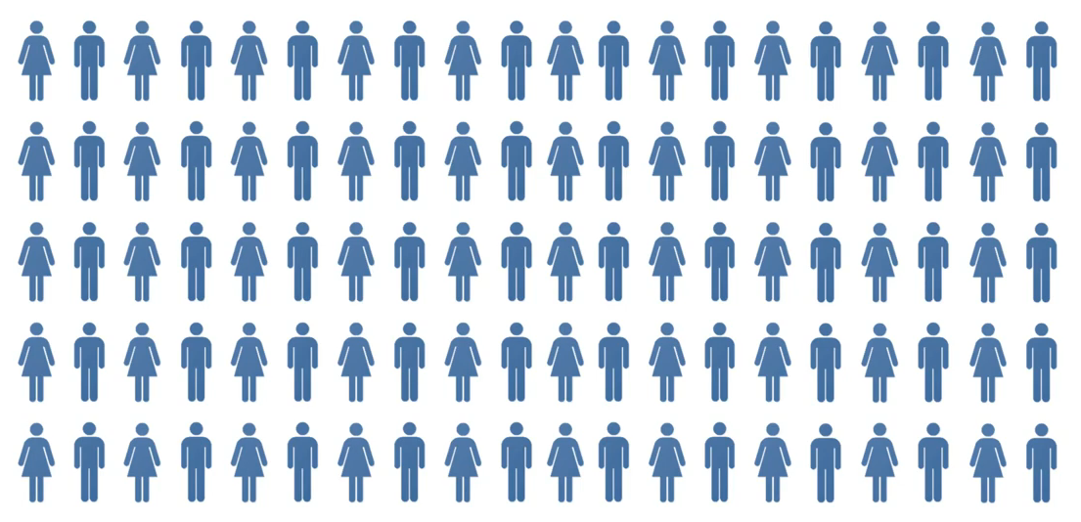

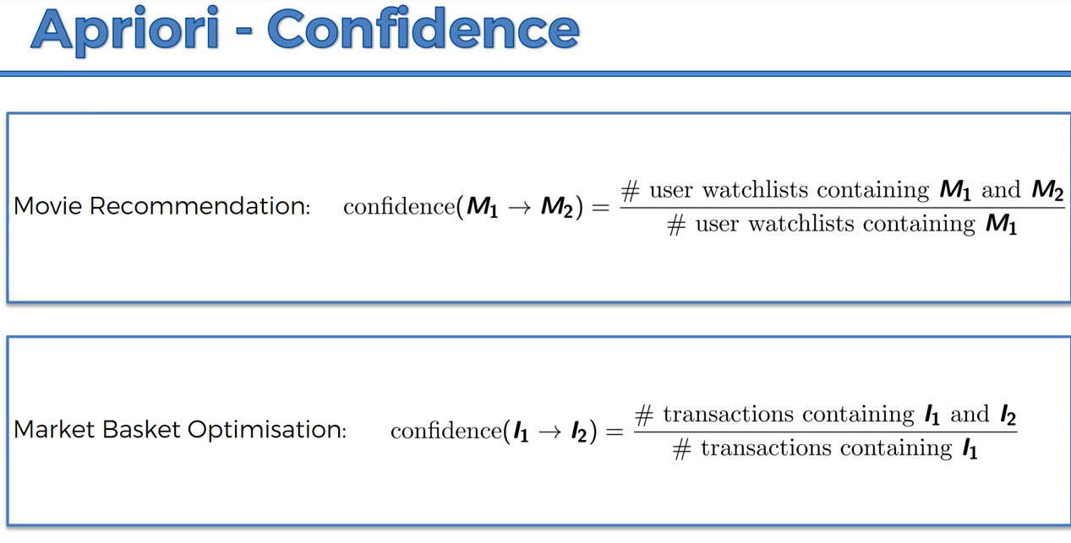

**I🡪Item, M🡪Movie**

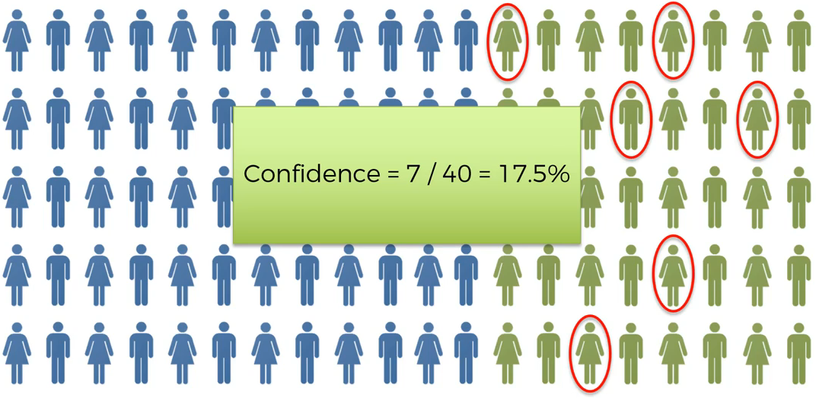

**Green🡪 interstellar**

**Green with red circle🡪 Ex machine movie**

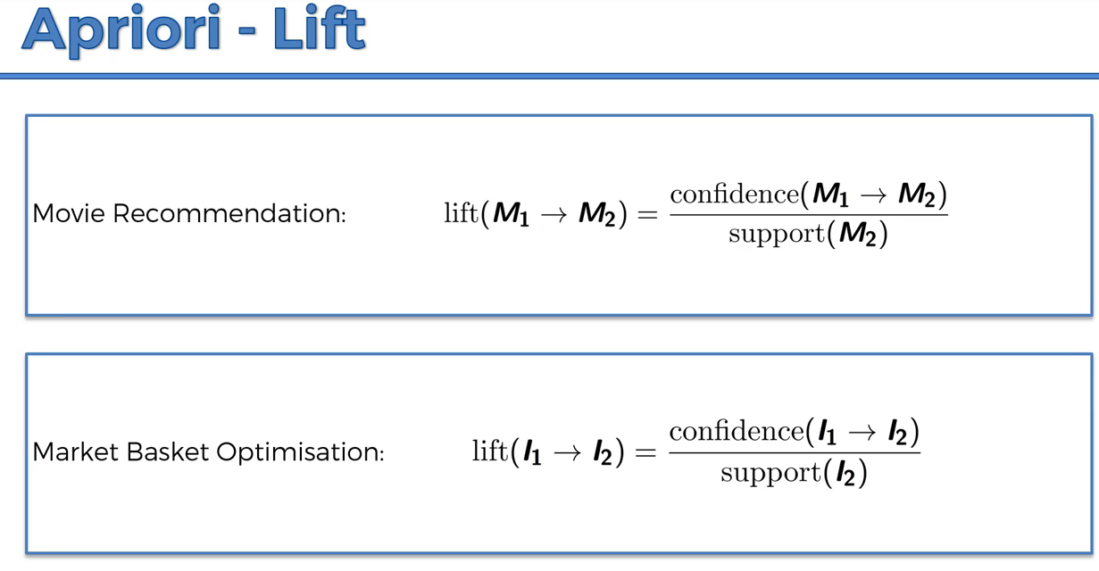

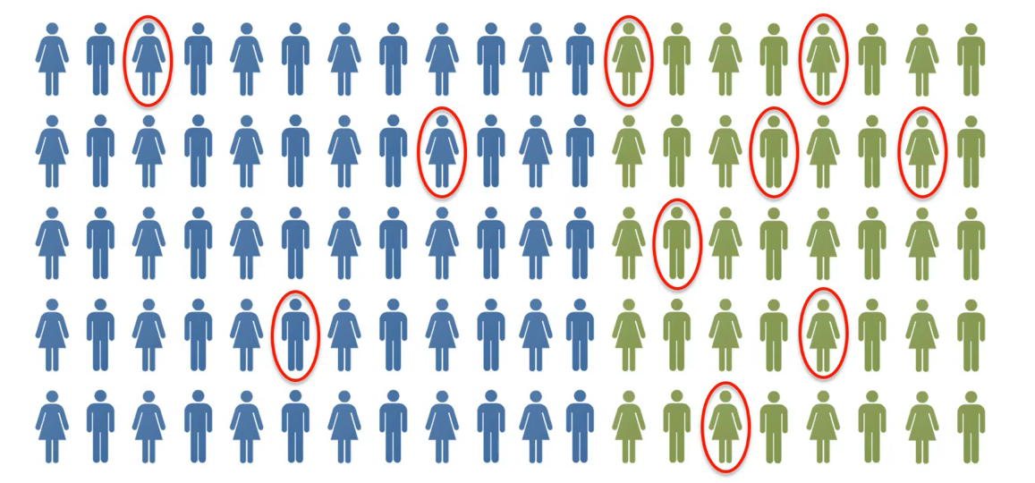

**Random suggestion 100 to 10 people likelihood to see ex-machina movie.(10%)**

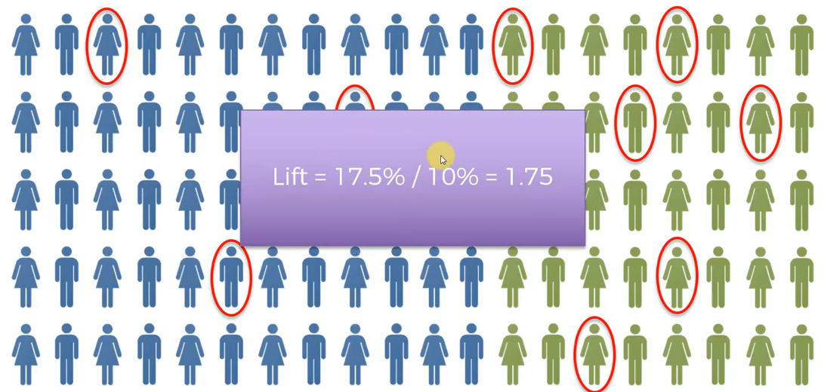

**10%--> Random**

**17.5🡪 people who like interstaller, like ex-machina by 17.5%**

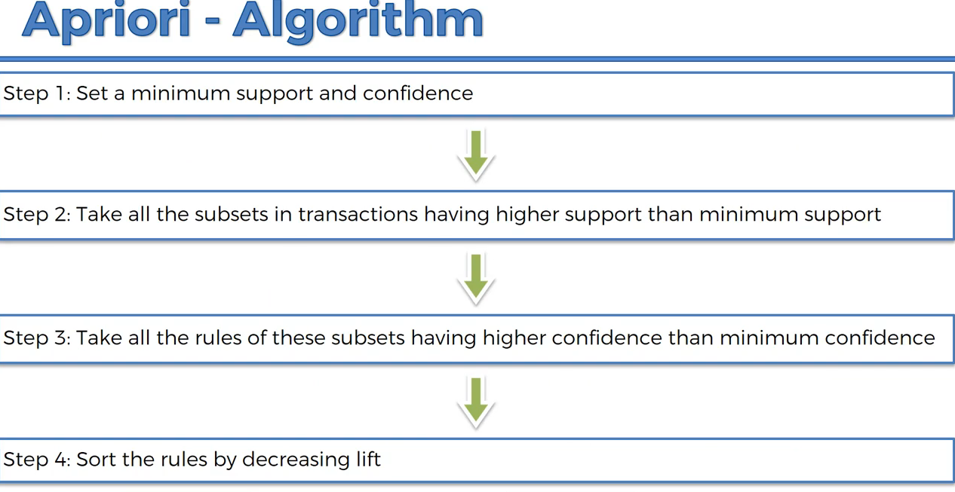

**Apriori is a slow algorithm since there will be so many probability.**